SRI JAYARAM INTITUTE OF ENGINEERING AND TECHNOLOGY COLLE

DROWSINESS DETECTION AND ALERTING SYSTEM

**Professional Readiness for Innovation, Employability and Entrepreneurship**

**PROJECT REPORT**

**Submitted by Team ID: NM2023TMID14700**

N.PARKAVI 113820121008

D.SAMUEL 113820121011

G.PRAKASH 113820106314

V.PANDIYAN 113820106313

**in partial fulfilment for the award of the degree of**

**BACHELOR OF ENGINEERING**

**BIO-MEDICAL ENGINEERING**

**SRI JAYARAM INSTITUTE OF ENGINEERING AND TECHNOLOGY UNIVERSITY: CHENNAI 600025**

**MAY 2023**

**BONAFIDE CERTIFICATE**

Certified that this project report “DROWSINESS DETECTION AND ALERTING SYSTEM” is the bonafide work of “ N.PARKAVI (113820121008), D.SAMUEL (113820121011), G.PRAKASH (113820106314)and V.PANDIYAN (113820106313)”, who carried out the project work under my supervision.

|  |  |
| --- | --- |
| TEAM ID | NM2023TMID14700 |
| PROJECT TITLE | DROWSINESS DETECTION AND ALERTING SYSTEM |

**Introduction;**

Driver fatigue has been the main issue for countless mishaps due to tiredness, tedious road condition, and unfavorable climate situations .Every year, the National Highway Traffic Safety Administration (NHTSA) and World Health Organisation (WHO) have reported that approximately million people die due to vehicle crashes across the world. Generally, road accidents mostly occur due to inadequate way of driving . These situations arise if the driver is addicted Countless of mishaps regarding road accidents are caused by fatigue, tiredness, and so on. About 50% of the accidents are road accidents. The road accidents can be due to inadequate way of driving, and these could arise if the driver is an alcoholic or drowsy. The drowsiness and the alcoholic condition of the driver has become a major cause for the road accidents. This also has led to major challenges in developing a system for the prevention of this issue. IOT-based innovation tends to be much more practical to work with since it runs on a real time system, and it can transfer all the data or information without any human interaction.

Fatigue is a safety problem that has not yet been deeply tackled by any country in the world mainly because of its nature. Drowsiness, in general, is very difficult to measure or observe unlike alcohol and drugs, which have clear key indicators and tests that are available easily. An IOT –based system is designed to avoid countless mishaps due to drowsy drivers’ behavioural and psychological changes by focusing on driver’s eye moments and health issues like heart attack, dizziness, and other health issues.

We’ll be focusing on the drowsiness aspect of it followed by checking other health parameters like pulse and alcohol detection. To obtain a solution to drowsy driving is extremely new and is set in motion. But the steps to prevent it with the help of IOT sensors and methodologies is what this paper discusses on IOT-based innovation will offer propelled dimensions of administrations and for all intents and purposes change the way individuals lead their day by day lives. Fatigue is a safety problem that has not yet been deeply tackled by any country in the world mainly because of its nature. Drowsiness, in general, is very difficult to measure or observe unlike alcohol and drugs, which have clear key indicators and tests that are available easily. An IOT –based system is designed to avoid countless mishaps due to drowsy drivers’ behavioural and psychological changes by focusing on driver’s eye moments and health issues like heart attack, dizziness, and other health issues. The main aim of this project is to develop a certain system which is efficient to predict the drowsiness and the health parameters of the driver using sensors to alert the driver and reduce the increasing number of accidents. The following are the problems we are going to tackle in our entire project:

1. Driver Drowsiness Detection
2. Alcohol Detection
3. Vehicle Locking System
4. Pulse Rate Monitoring System
5. Crash collision Detection

The basic purpose of this system is to track the driver’s facial condition and eye movements if the driver is feeling drowsy, then the system will trigger a warning message. When the drowsiness is detected, the driver is alerted by a buzzer. Measurement of different parameters of the driver such as Pulse Rate, Alcoholic Condition and Eye blink using the sensors like Heartbeat Sensor, Alcohol Sensor and Eye Blink Sensor respectively. There are many products out there that provide the measure of fatigue level in the drivers which are implemented in many vehicles. The driver drowsiness detection and health monitoring system provide the similar functionality but with better results and additional benefits. Also, it alerts the user on reaching a certain saturation point of the drowsiness measureSleep related crashes have received increasing attention during the latest decade. The National Transportation and Safety Board (US) has pointed out that sleepiness while driving is one of the most important contributing factors for road crashes (NTSB, 1999). Epidemiological studies based on self-reports or in-depth crash investigations show much higher figures compared to official crash statistics and suggest that about 10 to 20 percent of all crashes might be sleep or fatigue related (Horne & Reyner, 1995; Maycock, 1997; Stutts, Wilkins, Osberg & Vaughn, 2003; Stutts, Wilkins & Vaughn, 1999). It was also demonstrated in post-crash interviews that night driving, prior sleep below five hours, and the sleepiness level before the crash are major predictors of the risk of being involved in a road crash (Connor et al., 2002). In field studies (Dingus, Neale, Klauer, Petersen & Carroll, 2006; Hanowski, Wierwille & Dingus, 2003) sleepiness showed to be the major cause of self-caused crashes/near crashes. Recently, it was also shown that sleepiness may be a stronger cause of road crashes than alcohol and that they interact (Åkerstedt, Connor, Gray & Kecklund, 2008). Countermeasures to avoid sleep related crashes could be targeted to the human and be placed on the road, in the vehicle, but also more directed against the environment in terms of fatigue management programs, regulations etc. During the last years there has been an increased interest in developing driver support systems that identify sleepiness (Dinges, 1998). These systems normally consist of sensors for measuring physiological and behavioural changes, as well as algorithms to quantify such changes and predict risk. Common measures of driver sleepiness include the standard deviation of the lateral position (O'Hanlon & Kelly, 1974; Otmani, Pebayle, Roge & Muzet, 2005), which increases when the driver becomes sleepy. The electroencephalogram (EEG) with its content of alpha band (8-12Hz) and theta band (4-8Hz) activity (Horne & Reyner, 1996, Gillberg et al., 1996), as well as the electrooculogram (EOG) are other indicators sensitive to sleepiness, which are mostly used as reference values or gold truth. The latter may involve increased duration of eye blinks (Dinges, Maislin, Brewster, Krueger & Carroll, 2005) or slow rolling eye movements (Åkerstedt et al., 1990) both used as indicators in detection systems. Less effort has been targeted at the warning strategies, and how to provide the driver with feedback and/or a warning in a way that the sleepy

.

#### Abstract;

In current years, drowsy driver detection is the most necessary procedure to prevent any road accidents, probably worldwide. The aim of this study was to construct a smart alert technique for building intelligent vehicles that can automatically avoid drowsy driver impairment. But drowsiness is a natural phenomenon in the human body that happens due to different factors. Hence, it is required to design a robust alert system to avoid the cause of the mishap. In this proposed paper, we address a drowsy driver alert system that has been developed using such a technique in which the Video Stream Processing (VSP) is analyzed by eye blink concept through an Eye Aspect Ratio (EAR) and Euclidean distance of the eye. Face landmark algorithm is also used as a proper way to eye detection. When the driver’s fatigue is detected, the IoT module issues a warning message along with impact of collision and location information, thereby alerting with the help of a voice speaking through the Raspberry Pi monitoring system.

**Proposed System;**

The proposed system here is designed to minimise the occurrence of countless mishaps due to the drowsy driver. Nowadays, fatigue of driver causes road accidents every now and then across the world. So, these activities should be required to automatically handle an implementation of smart alert system or vigilance in a vehicle which is an objective of this system. To analyze different behavioral or visual-based attitudes of the driver, face movement and eye blink are measured to study the state of the driver. Here, eye blink is mainly focused to detect drowsiness of the driver. The threshold value of an EAR lies above 0.25 without any effect of exhaustion. When a driver automatically shuts down, then the threshold value of EAR falls below the given range. A threshold value of drowsy eye blink sample represents the number of video frames of the driver’s closed eyes. If the consecutive counting frames increase above the range of the threshold value, then the drowsiness of the driver is detected. Here, a Pi camera is used to regularly record the total movement of an eye through which the threshold value of an EAR is calculated. A counter is also included in it for counting occurrence of frames. Suppose that it exceeded above a range of 30. In that case, a voice is activated by a speaker and a mail is automatically sent to an authorized person of the vehicle which is generally processed at the time of drowsiness detection. The described modules work properly through Raspberry Pi3 which is programmed in Python programming language. Figure [3](https://www.hindawi.com/journals/wcmc/2021/6627217/fig3/) depicts a test scenario of the proposed system.

[[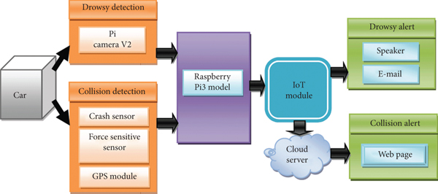](https://www.hindawi.com/journals/wcmc/2021/6627217/fig3/)](https://www.hindawi.com/journals/wcmc/2021/6627217/fig3/" \t "_blank)

#### Proposed Methodolog;

When the Pi camera model V2 is successfully integrated with Raspberry Pi3, it continuously records each movement of the driver’s face. This proposed work specially focuses on behavioral measures of the driver with severity measurement of collision in following sections. The EAR is accurately calculated due to the use of Raspberry Pi3 model B and Pi camera modules to make a persistent recording of face landmarks that are localized through facial landmark points. But the Raspberry Pi3 model B and Pi camera modules are securely processed due to the operating system of the controller and predictable secure shell (SSH) keys. The use of SSH host keys provides secure network communications and helps to prevent unauthorized communications or file transfers. The IoT-based application is being developed through the integration of some IoT modules like wireless sensors, GPS tracker, Pi camera, and smart code for detecting drowsiness of the driver. So the above modules are properly integrated with the Raspberry Pi controller module that intelligently controls and smartly warns a drowsy driver. The successful integration of IoT modules is robustly used to prevent the cause of mishaps and also warns the drowsy driver to avoid careless driving. The Internet of Things (IoT) is helping to manage various real-time complexities like handling complex sensing environments and also provides a very flexible platform to control multiple connectivities. The IoT module is a very reliable way of capturing images of the drowsiness of the driver as well as sending an alert message to the owner for awareness.

EMPATHY MAP

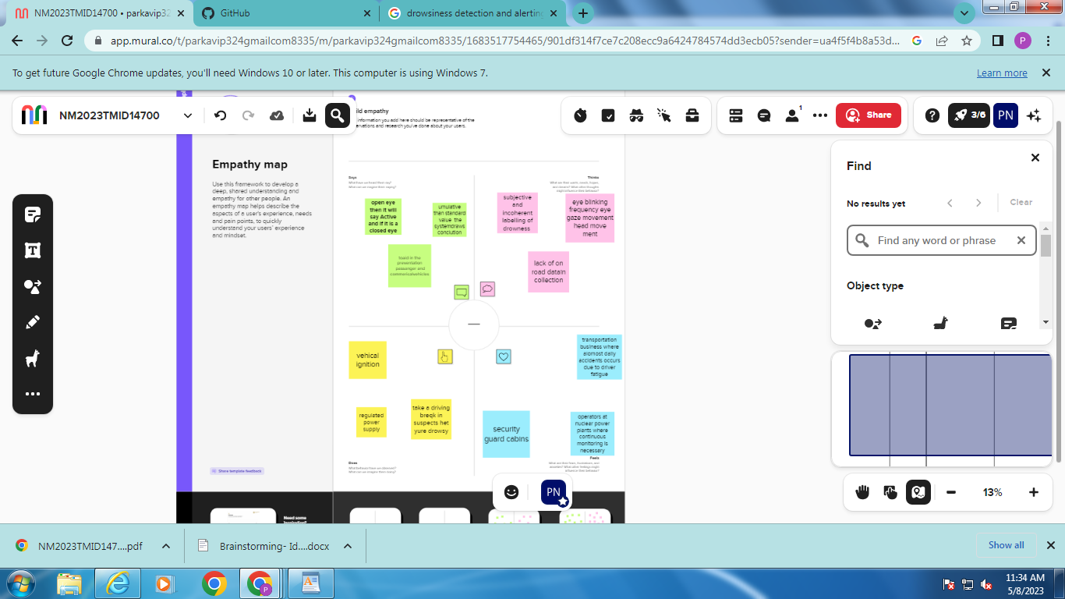

BRAIN STORMING





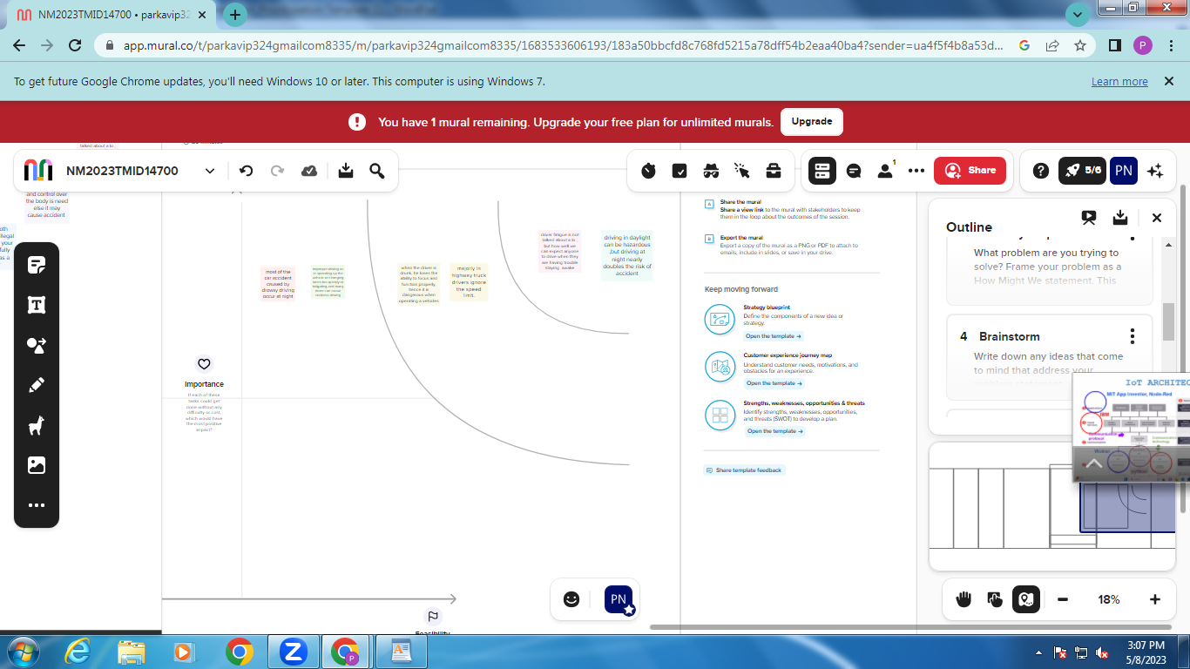

PROBLEM STATEMENT;



**Prediction of Drowsiness;**

When the driver has not fallen into drowsiness that is graphically represented in Figure and detected the EAR value is greater than 0.25, it indicates the eyes are open. This test shows that the face is not recognized as a drowsy one. Similarly, the drowsiness of the driver is detected due to the EAR value being less than 0.25 as graphically plotted .and finally, a drowsy face is detected . The EAR values are frequently changed due to movements of the eyelids as shown in above figure. When the drowsiness is found, then the driver is alerted with repeated voice sound and an email message is forwarded to the owner or related authority. Here, speech speaker is implemented instead of buzzer for more vigilance; if it fails, then the owner will provide any warnings after receiving the message from its mail as represented .

[[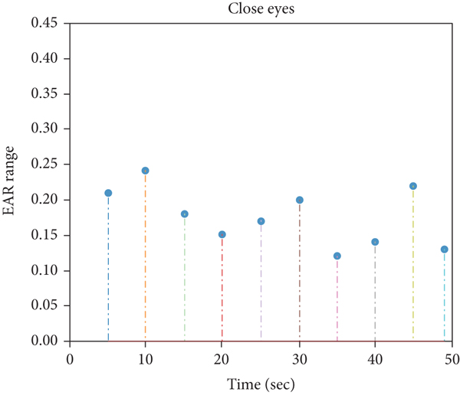](https://www.hindawi.com/journals/wcmc/2021/6627217/fig8/)](https://www.hindawi.com/journals/wcmc/2021/6627217/fig8/" \t "_blank)**[(b)](https://www.hindawi.com/journals/wcmc/2021/6627217/fig8/" \t "_blank)**

[[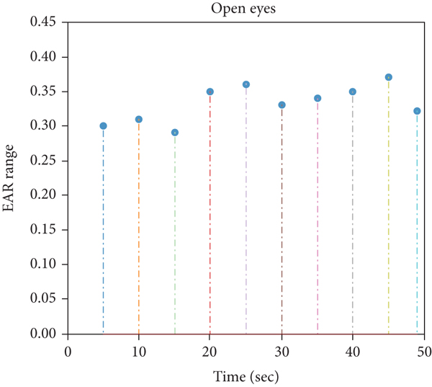](https://www.hindawi.com/journals/wcmc/2021/6627217/fig8/)](https://www.hindawi.com/journals/wcmc/2021/6627217/fig8/" \t "_blank)

Limitations;

In order to limit the discussion to a manageable extent, a number of preconditions were assumed to be fulfilled. They are described in the following paragraphs. Additionally, definitions relevant for this paper are provided. For the present paper the existence of a system is assumed, which is diagnosis or prediction based, with high sensitivity and specificity, having a high acceptance and high effectiveness. The human machine interface (HMI) is designed in an acceptable way, and behaviour, and not so much on the evaluation of the quality of the system functionality in itself. There is also a difference depending on whether we are interested in looking at changes over time (repeated sequences) or occurrences of single events. It is important to decide how to measure the effect of a warning. One more critical question is how to evaluate the effects of repeated events or series of events that could appear in different order. This is not considered within this paperthe warnings are generally perceived as correct. The warning is based on a detection system that uses different measures as input. The warning is based on a combination of modalities with an optimal frequency and amplitude. The participants are representative. The focus of this article is on advantages and disadvantages of different methods with respect to the evaluation of the effect of such a system on driver behaviour and driving.

Conclusion;

behaviour, and not so much on the evaluation of the quality of the system functionality in itself. There is also a difference depending on whether we are interested in looking at changes over time (repeated sequences) or occurrences of single events. It is important to decide how to measure the effect of a warning. One more critical question is how to evaluate the effects of repeated events or series of events that could appear in different order. This is not considered within this pap erafter a given warning while keeping a high level of control and a low degree of confounding with other factors. It is necessary and possible to use more controlled setups during feasibility studies and for tuning warning strategies and modalities.

Advantage;

A drowsiness detection and alerting system offers several advantages, particularly in the context of enhancing road safety. Here are some of the key benefits:

1. Accident Prevention: Drowsiness is a major cause of road accidents. By detecting signs of drowsiness in drivers, such as drooping eyelids or erratic steering patterns, the system can alert the driver to take corrective action, preventing potential accidents caused by inattentiveness or falling asleep at the wheel.

2. Early Warning: The system can provide early warnings to drivers, allowing them to take necessary measures before the situation becomes critical. By detecting the initial signs of drowsiness, such as yawning or reduced eye movement, the system can alert the driver to take a break, drink coffee, or perform other activities to combat drowsiness.

3. Increased Driver Awareness: The continuous monitoring of driver behavior helps increase self-awareness by reminding drivers to stay focused and alert. The system acts as an additional safety measure, encouraging drivers to maintain a higher level of attentiveness and reducing the likelihood of drowsiness-related accidents.

4. Customizable Alerts: Drowsiness detection and alerting systems can be tailored to individual driver preferences and needs. The system can be programmed to deliver alerts in various ways, such as audible alarms, seat vibrations, or visual warnings, ensuring that the driver is notified effectively and promptly.

5. Improved Road Safety: By reducing the occurrence of drowsiness-related accidents, these systems contribute to overall road safety. They help prevent injuries, save lives, and minimize property damage by addressing one of the significant causes of accidents on the road.

6. Long-Distance Driving Support: Drowsiness detection systems are particularly valuable for long-distance driving, where fatigue and drowsiness tend to be more prevalent. Drivers undertaking extended journeys can benefit from the system's continuous monitoring and alerts, enabling them to stay alert and arrive at their destination safely.

7. Data Insights: These systems can collect valuable data on driver behavior, which can be analyzed to identify patterns and trends related to drowsiness. Such insights can be used to develop improved driver training programs, design safer road infrastructure, or implement policies and regulations aimed at reducing drowsiness-related accidents.

Overall, drowsiness detection and alerting systems play a crucial role in mitigating the risks associated with drowsy driving, promoting road safety, and saving lives.

Disadvantages;

While drowsiness detection and alerting systems can be beneficial in various contexts, they also have certain disadvantages. Here are a few drawbacks associated with such systems:

1. False Alarms: Drowsiness detection systems may sometimes generate false alarms, indicating drowsiness or fatigue when the driver or individual is actually alert. False alarms can be disruptive and lead to unnecessary interruptions, potentially causing annoyance and decreased trust in the system.

2. Limited Accuracy: Although drowsiness detection systems have improved over time, they may still have limitations in accurately identifying drowsiness. Factors such as lighting conditions, variations in individual physiology, and other environmental factors can impact the system's ac…

**RESULTS**

Our project has a capability of detecting the drowsiness, alcohol, pulse rate and obstacle detection to reduce accidents. If the alcohol and drowsiness is detected the ignition key is turned off and the SMS will be sent to the respective family member and the location of the driver as shown in Fig 4. Having that feature allows the driver’s family or relatives to locate the driver quickly if gotten to any accidents.